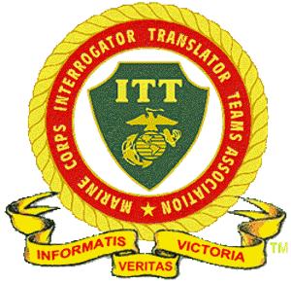
Marine Corps Interrogation Translation Teams Association
Upcoming Zoom Meeting

Tues, May 11- The Commandant's Force Design With Emphasis In The Pacific

To MCITTA Members and Friends,
Reminder - we are 2 weeks away from this event!
Our guest speaker MajGen James Lukeman USMC (Ret) is set to present on Zoom to MCITTA on May 11, 1000 hrs PT. His topic will be,
The Commandant's Force Design With Emphasis In The Pacific
MajGen Lukeman will focus on The Commandant's Force Design and the challenge of operating in the Pacific. He’ll rely heavily on his experience in Korea and talk about how the Marine Corps will fight in the Pacific along with the importance of our Pacific allies. In a nut shell, how we are preparing to fight in the Pacific.
His biography can be found at the Marine Corps Heritage Foundation link below, where he is President and CEO.
https://www.marineheritage.org/our-leadership--team.html
The Zoom registration link is below.
Register in advance for this meeting:
https://us02web.zoom.us/meeting/register/tZUtfu2pqTIoHtF29fWwalP7dfRrJu0jAaQm
After registering, you will receive a confirmation email containing information about joining the meeting.
Make your Zoom registration and do not miss this event!
Semper Fi!
Jim Tortorici, Chairman MCITTA

